AI Based Exam Proctoring System
Project Name: PRISM
Acronym: Proctoring with Reliability, Intelligence, Security, and Monitoring
Tagline: Integrity Beyond Surveillance

LOGO:


- Abstract

The rapid growth of online education has increased the demand for secure and reliable remote examination systems. Traditional online exams lack effective monitoring mechanisms, making them vulnerable to malpractice such as impersonation, unauthorized assistance, and cheating. To address these challenges, this project presents PRISM (Proctoring and Remote Integrity Surveillance Mechanism), an AI-based Exam Proctoring System designed to ensure examination integrity in a scalable and user-friendly manner.
PRISM leverages artificial intelligence and computer vision techniques to monitor candidates during online examinations. The system performs real-time face detection, identity verification, and behavior analysis to detect suspicious activities such as multiple faces, absence of the candidate, abnormal head movements, and use of external devices. Audio monitoring and event logging further strengthen the reliability of the examination process. All detected events are securely stored for post-exam review.

The application follows a role-based access control model with a unified login system and dynamically adaptive user interfaces for administrators, examiners, and students. Secure authentication is implemented using JWT-based token management, ensuring authorized access and data protection. PostgreSQL is used as the backend database for structured storage of users, roles, exams, and monitoring logs, while a lightweight HTML, CSS, and JavaScript frontend ensures accessibility without reliance on heavy frameworks.
PRISM is designed with a modular and maintainable architecture, enabling future scalability and integration of advanced AI features. By combining security, transparency, and usability, the system provides a practical and effective solution for conducting fair and trustworthy online examinations.

2. Introduction
Online education has become an integral part of modern learning systems. Universities, certification bodies, and training platforms increasingly rely on online examinations to assess learners remotely. While this shift offers flexibility and scalability, it also introduces serious concerns related to exam integrity, identity verification, and unfair practices. Traditional examination systems depend on physical invigilation, which is not feasible in remote environments.
PRISM is designed as an AI-based Exam Proctoring System that addresses these challenges by acting as a virtual invigilator. The system continuously monitors candidates during online examinations using intelligent algorithms while ensuring that the examination experience remains fair, transparent, and user-friendly.

3. Problem Statement
Remote online examinations face multiple challenges that compromise fairness and credibility. The absence of physical supervision makes it easier for candidates to engage in malpractice such as impersonation, consulting external resources, or receiving external assistance. Manual online proctoring requires a large number of human invigilators, making it costly and inconsistent.
The core problem addressed by this project is the lack of a scalable, unbiased, and intelligent monitoring system that can ensure exam integrity without excessive human intervention. Existing solutions are either intrusive or fail to provide consistent enforcement of rules.

4. Objective of the Project
The primary objective of PRISM is to design and implement an automated exam monitoring system that ensures fairness and security in online examinations. The system aims to reduce dependency on human proctors while maintaining transparency and minimizing stress for students.
Key objectives include:
- Ensuring continuous monitoring throughout the exam
- Detecting suspicious behaviour using AI techniques
- Providing real-time alerts and post-exam reports
- Supporting role-based access for different users

5. Proposed Solution
PRISM provides an intelligent solution by combining Machine Learning, Computer Vision, and browser-level monitoring techniques. The system uses the candidate’s webcam and microphone to analyze behaviour patterns such as face presence, audio anomalies, and screen activity.
Instead of relying on a single rule, PRISM evaluates multiple parameters simultaneously to determine whether an activity is suspicious. This multi-dimensional analysis ensures higher accuracy and fairness compared to traditional rule-based systems.

6. System Scope
The scope of PRISM is limited to online examination monitoring and integrity assurance. The system does not handle grading or academic evaluation but focuses entirely on ensuring that examinations are conducted fairly.
In scope functionalities include webcam-based monitoring, audio analysis, browser activity tracking, role-based dashboards, and report generation. Offline examinations and hardware-based biometric systems are considered outside the scope of this project.

7. User Roles and Role-Based Access Control
PRISM follows a Role-Based Access Control (RBAC) system to ensure both security and clarity in online examination management. Each user is assigned a specific role — Student, Examiner, or Admin — which determines what they can access and how their interface is structured.
Roles Definitions
- Student: The primary user who takes online examinations. Students are monitored by the AI system during the exam to maintain integrity. Their dashboard displays available exams, instructions, and system compatibility checks.
- Examiner: Responsible for creating, scheduling, and managing exams. Examiners also monitor active exams through live dashboards, review AI-generated alerts, and assess reports after exam completion.
- Admin: Oversees the overall system, manages users and roles, configures AI monitoring rules, and audits logs and analytics. Admins have full system access but actions are protected to prevent accidental misuse.
Access Control
PRISM ensures that each role can only access functions relevant to their responsibilities:
- Students can only take exams and view instructions.
- Examiners can create exams, monitor students, and view reports.
- Admins have access to system-wide settings, user management, and analytics.
This separation of access is critical for security, fairness, and the principle of least privilege, preventing unauthorized access to sensitive features.
UI/UX Design Per Role
The user experience for each role is tailored to their tasks while maintaining consistency and ease of use:
- Student UX: A clean, distraction-free dashboard showing only exams and instructions. During the exam, a split-screen interface displays questions on the left and AI monitoring indicators (webcam feed, audio status, warning alerts) on the right. Warnings are gradual and transparent to reduce stress.
- Examiner UX: A dashboard that presents live feeds of students with status indicators (Normal / Warning / Violation). Important alerts are highlighted, and report access is streamlined for efficiency. The interface prioritizes critical information without overwhelming the user.
- Admin UX: A system control panel for managing users, roles, and AI rules. Access to sensitive functions is isolated, and audit logs are easy to navigate. Analytics dashboards provide quick insights without clutter.

Dynamic UI Behaviour and Reasoning
Although all users log in via the same page, PRISM dynamically loads the dashboard and features according to the user’s role:
- Single Login: Simplifies authentication and reduces the need for multiple login pages. Users select their role at login or the system detects it automatically.
- Dynamic Role-Based Dashboard: After authentication, the system loads a custom UI tailored to the role, ensuring that users only see relevant controls and information.
- Design Rationale: This approach balances simplicity, security, and usability. Students are not distracted by admin or examiner features, examiners can monitor efficiently without unnecessary clutter, and admins can manage the system safely.

8. Database Management Using PostgreSQL
- PostgreSQL is used as the backend relational database to securely store and manage application data such as users, roles, examinations, questions, and AI-based monitoring logs, ensuring data integrity, security, and reliable data handling.

Database Tables Used
Table Name | Description
Roles | Stores different user roles such as Student, Examiner, and Admin for role-based access control.
Users | Stores user details including name, email, encrypted password, and assigned role.
Exams | Stores information related to exams such as exam title and examiner details.
Questions | Stores exam questions along with multiple-choice options and correct answers.
Monitoring Logs | Stores AI-detected activities during the exam such as face absence, multiple faces, background noise, and tab switching events.

9. Application Design and Layout
The PRISM application is designed to provide a seamless and secure user experience while integrating AI-based exam monitoring. The design focuses on clarity, role-specific dashboards, and responsive interfaces that adapt to each user’s needs.
UI/UX Design
The system uses a single login page for all users (Student, Examiner, Admin) to simplify authentication. After login, the system dynamically loads the dashboard according to the user’s role.
- Student Dashboard: Displays upcoming exams, instructions, and system compatibility checks. During the exam, a split-screen interface shows questions on the left and live AI monitoring indicators on the right, including webcam feed, audio status, and warnings. Alerts are transparent and gradual to reduce anxiety.
- Examiner Dashboard: Provides a live view of candidates with status indicators (Normal / Warning / Violation). Critical alerts are highlighted, and reports are easily accessible. The interface is streamlined to prevent cognitive overload while monitoring multiple candidates.
- Admin Dashboard: Allows system configuration, user management, rule settings, and auditing. Sensitive operations are isolated and clearly indicated to prevent accidental misuse. Analytics dashboards provide insights at a glance.
Frontend Technologies
- HTML, CSS, and JavaScript: Chosen for simplicity, broad browser compatibility, and fast loading times. They provide the foundation for all user-facing pages, ensuring that students and staff can access the system without requiring heavy dependencies or specialized software.
- WebRTC: Used to access webcam and microphone streams in real time. This enables AI monitoring to process live video and audio data securely.
- Fetch API / AJAX: Facilitates communication with the backend server for dynamic content loading, submission of exam responses, and retrieval of monitoring alerts.

Backend Technologies
- Python: Selected for its rich ecosystem in AI and machine learning, making it ideal for integrating facial recognition, behavior analysis, and anomaly detection models.
- Flask: A lightweight Python web framework that supports RESTful API development, session handling, and easy integration with AI modules. Flask allows rapid development and scalability for handling multiple concurrent exams.
- OpenCV: Used for computer vision tasks such as face detection, eye movement tracking, and monitoring head orientation. OpenCV is robust, reliable, and widely used in academic and professional projects.

Security Implementation
- JWT (JSON Web Token): JWT is implemented for secure, stateless authentication. Upon successful login, the server issues a signed JWT containing user identity and role information. The token is stored in local/session storage on the client and sent with every request to verify access.
  - Role Enforcement: The backend uses JWT claims to dynamically render role-specific dashboards and restrict access to unauthorized endpoints.
  - Data Integrity & Security: JWT ensures that tokens cannot be tampered with. Any modification invalidates the token, preventing unauthorized access or privilege escalation.
- HTTPS & Encryption: All API communication is encrypted over HTTPS to protect sensitive data, including exam content, video feeds, and student information.

Integration & Application Flow
The frontend and backend communicate via RESTful APIs. For example:
- After login, the frontend sends credentials to the backend.
- The backend authenticates the user, issues a JWT, and returns role-specific data.
- The frontend renders the appropriate dashboard based on the JWT payload.
- During exams, video and audio streams are continuously sent to the backend for AI processing.
- Alerts and monitoring results are returned to the frontend in real time and displayed to the user (or examiner).
This integration ensures secure, role-specific, and real-time monitoring, combining usability with strong security practices.

Design Rationale
By combining lightweight frontend technologies, Python-based backend, AI integration, and JWT authentication, PRISM achieves:
- Security: Prevents unauthorized access and protects sensitive data.
- Scalability: Supports multiple concurrent exams without heavy resource requirements.
- Transparency: Students are aware of monitoring indicators, reducing stress and building trust.
- Maintainability: Clear separation of frontend, backend, and AI components allows easier future enhancements.

10. Application Workflow
The application workflow begins with user authentication and role identification. Once authenticated, users are redirected to their respective dashboards. Before the exam begins, the system performs a compatibility check for camera, microphone, and network stability.
During the exam, PRISM continuously monitors candidate behaviour and applies AI-based analysis. Any detected violations trigger warnings or automated actions. After exam completion, a detailed monitoring report is generated for examiner review.
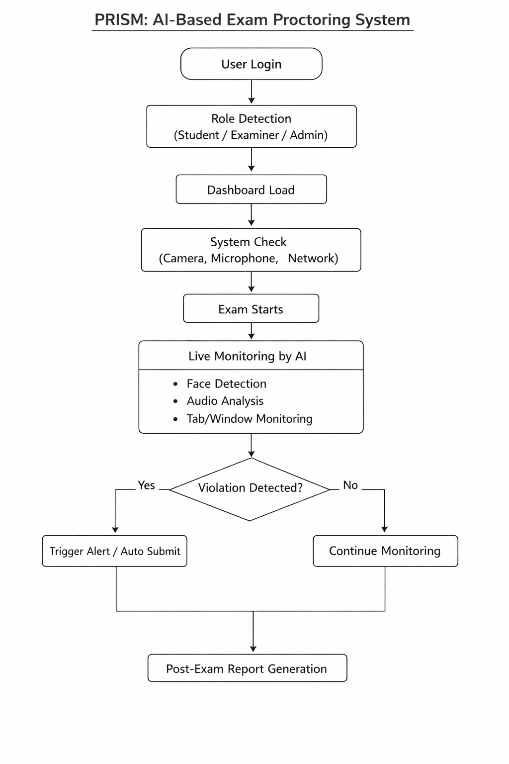

11. Technical Architecture
The frontend of the system is developed using HTML, CSS, and JavaScript to ensure fast loading and wide compatibility. WebRTC is used to access camera and microphone streams, while the Fetch API enables communication with backend services.
The backend is implemented using Python and Flask, which provides a lightweight and scalable framework for handling authentication, data storage, and AI processing. Machine learning models and computer vision algorithms are integrated into the backend to analyze incoming data streams.

12. Technology Selection Rationale
HTML, CSS, and JavaScript were chosen for the frontend due to their simplicity, accessibility, and ease of maintenance. Flask was selected for the backend because it allows rapid development and seamless integration with Python-based AI libraries.
Python was chosen as the core programming language due to its strong ecosystem for machine learning and computer vision. OpenCV is used for image processing tasks such as face detection due to its reliability and wide industry adoption.

13. User Experience Considerations
PRISM is designed to be transparent rather than intrusive. Monitoring indicators are visible to students to ensure trust, while warnings are gradual instead of immediate penalties. The interface avoids unnecessary animations or distractions to reduce exam-related anxiety.
Accessibility considerations such as clear typography and simple navigation are incorporated to ensure usability for a wide range of users.

14. Limitations and Future Enhancements
The system’s performance depends on camera quality and network stability. Advanced behavioural analysis such as emotion detection is beyond the scope of the current implementation.
Future enhancements may include gaze tracking, advanced anomaly detection models, multi-camera support, and detailed analytics dashboards for examiners.

15. Conclusion
PRISM represents a thoughtfully designed AI-based exam proctoring system that balances technological capability with ethical and user-centric design. By focusing on intelligent automation, clear system architecture, and transparent monitoring, the project provides a practical and scalable solution to modern online examination challenges.
The project demonstrates strong problem understanding, sound technical decisions, and realistic implementation choices, making it suitable for academic evaluation and professional discussion.

